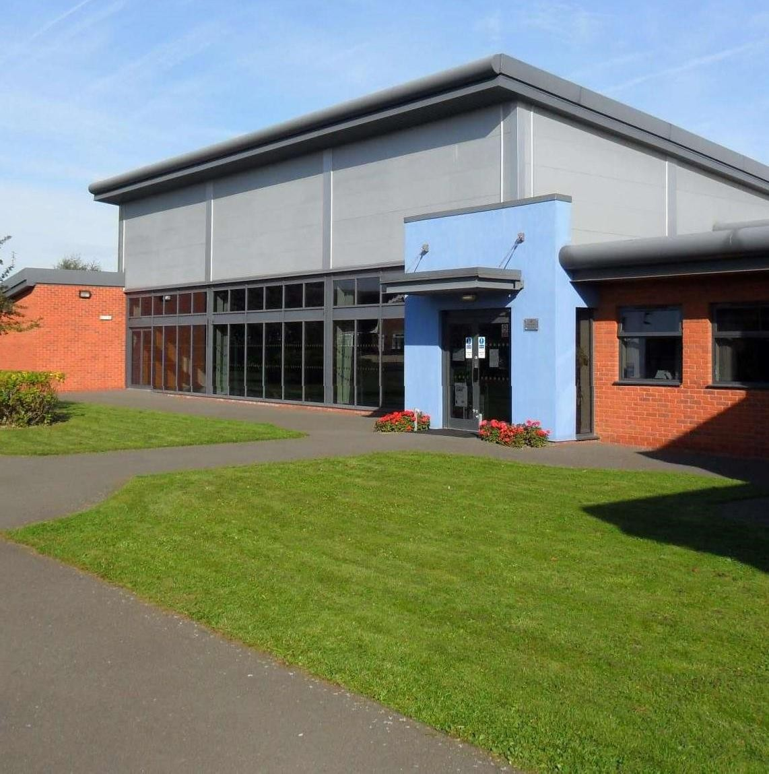


Starting
Starting
School

School

2025-2026

Farnsfield St Michael’s C of E Primary School
1

School Contact Details:
The school office opening times are Monday to Friday 8.15am-4.30pm.

Address:

Farnsfield St Michael’s C of E Primary School Branston Avenue
Farnsfield Newark Notts NG22 8JZ

Telephone:

01623 882494

Website:

https://www.fsmp.org.uk/

Email:

Office@fsmp.org.uk

Welcome to St Michael’s
This booklet has been created to help prepare you and your child for joining our school community. Here you will find information about our school and ideas for how to prepare for starting Foundation in September. We are excited to welcome you and join you on your child’s journey through their education with us.
We recognise the importance of the relationship between the school and the family and want to work together with you to enable your child to love learning and reach their full potential. If you have any questions or queries, do not hesitate to contact us at school.

“My commandment is this: Love one another as I have
loved you.” John 15 v 12


Vanessa Foxall Vicki Collett
EYFS Lead Class Teacher

Our School Vision and Values
Our vision is deeply rooted in love, unlocking potential and opening doors through our shared Christian faith. A beacon in the wider community, guiding others and shining light on one another to live well together. Creating well- rounded individuals who flourish and celebrate life in all its fullness through a broad and balanced curriculum and wider opportunities; developing wisdom, knowledge and skills. Treating each person as a unique individual, celebrating differences; showing dignity and respect for all. Joining together on the same path, whatever the starting point, to guide one another to fulfil our full potential with hope and aspiration. We have seven Rainbow Values that underpin all that we do.

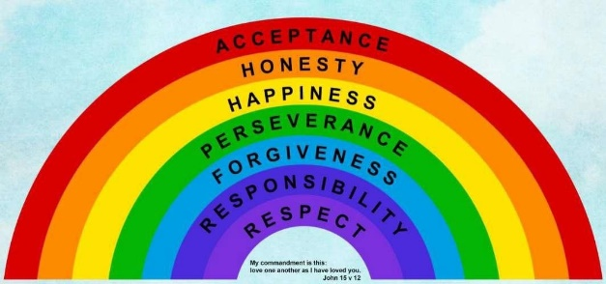
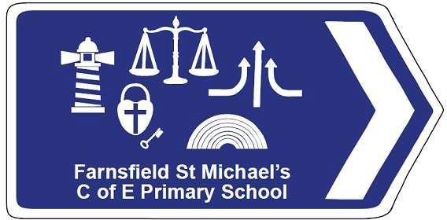

Louise Carpenter
Head Teacher

General Information:

The School Day
The school day begins at 8.45am when children will be welcomed into the classroom by their teacher. This will be the Foundation classrooms which are accessed by coming from the main playground through the green wooden
gate. We are operating a ‘soft start’ whereby you can drop your child off between 8.40 and 8.50am and pass on any messages to the teacher. The door will be closed at 8.50am so that the register can be taken. If you arrive after 8.50am please take your child to the school reception to sign in. They will be marked as late, so we do encourage punctuality. The school day finishes at 3.20pm when you will collect your child from their classroom door. Please wait on the Foundation playground until doors open for children to be dismissed by the class teacher.
The Autumn Term starts on Wednesday 3rd September 2025. We would like the children to come to school for the morning on this day. Please bring your child into school via the Foundation playground and pick them up from the main reception at 12pm. On Thursday 4th September, please also bring your child to school for the morning and pick them up from the main reception at 12pm. On Friday 5th we invite the children to spend their first lunchtime with us. Please collect your child from the main reception at 1pm. From Monday 8th September children will be with us full-time.

We have a Before and After School Club for wrap around care. Sessions can be booked and paid for via ParentPay, our cashless payment system. Mrs Shine will email you directly before the Summer break with individual login details for ParentPay and further instructions on how to book sessions for your child for the coming academic year. The sessions will be made available to you at the same time as our current pupils (around 4th July), so everyone has the same opportunity to reserve the sessions they will need. Mrs Carpenter has increased the number of spaces at the club, so we have more than enough availability.

Attendance

It’s really important that children attend school every day so that they can make good progress in their learning. If your child is ill and cannot attend school, please call the school office in the morning so that we can record their absence. Please call each morning of their absence to keep us informed. If your child becomes ill during the school day, a phone call will be made to you to come and collect them.

We encourage you to arrange medical appointments outside of school hours but know this is not always possible. In this instance, please let the school office and your child’s class teacher know in advance and you will be requested to provide the office with an appointment confirmation.


Bethan Shine Office Administrator

School Uniform
Our school uniform consists of:

- A royal blue cardigan or jumper (plain or with the school logo)
- A white polo shirt
- Grey trousers, skirt or pinafore
- Black school shoes or boots – no trainers
- Coat appropriate for the weather
- Grey shorts or a blue summer dress may be worn in the warmer months


We also ask Foundation children to have wellies kept in school too, for our outdoor sessions.

It is important children wear the correct clothing for PE sessions to keep them safe whilst active. Our PE kit consists of:
- White t-shirt
- Black shorts
- Black jumper and trousers for outdoor PE in the colder months
- Trainers

Children will come to school in their PE kits on their designated PE days. Your child’s class teacher will communicate with you when your child has PE at the beginning of the Autumn Term.

Children will also need to bring a book bag every day containing their school reading record, reading books and any letters that are sent home and returned completed.

Please ensure that ALL items of clothing and belongings are clearly labelled with
your child’s name. Any lost items without labels, will be sent to the ‘Lost Property’ box in the school reception.


All items can be purchased online through the uniform shop on our school website, under the tab Parents > Useful Links. You can also purchase name labels from this page of the website too.

Good quality secondhand uniform is also available from ‘Inspirations’ charity
shop in the village.

Lunchtimes
Children in Foundation, Year 1 and Year 2 are entitled to a universal free school meal each day. These are delicious, nutritious hot meals that are cooked daily on site in our school kitchen. There is a weekly menu that can be viewed on the Innovate website, you can then discuss the options with your child. We also provide a vegetarian choice and a daily jacket potato option. If your child has any allergies or intolerances these will be accommodated. School meals must be booked in advance via the Innovate Food website. If you prefer, you are welcome to provide your child with a packed lunch. We ask that these are healthy foods – no fizzy drinks or sweets. We are also a nut free school.

Snack time
Each day children will be provided with a piece of fresh fruit for a morning snack. Up until their fifth birthday, children are entitled to a free carton of milk with their snack but you must sign them up to receive this via the Coolmilk website. When they turn five, this must be paid for if your child would like to continue having milk. Children will also need to bring a named water bottle to school each day as we encourage them to drink water throughout the day.

Preparing your child for school

How we prepare your child for school
At St Michael’s, we understand how important the transition process is to help your child settle into school. We hope your child can attend the transition events that are taking place before the summer holiday.

We are currently talking with the children’s pre-school settings to help us get to know the children a little better. We do a range of face-to-face, telephone and written communications with current settings to help us make the transition to St Michael’s as smooth as possible.

In September, we spend the first few weeks, observing and playing with your child to get to know them, their interests and strengths to help us guide them
on their learning journey through the Foundation Stage.

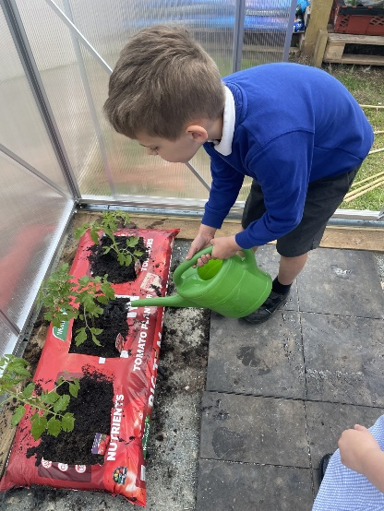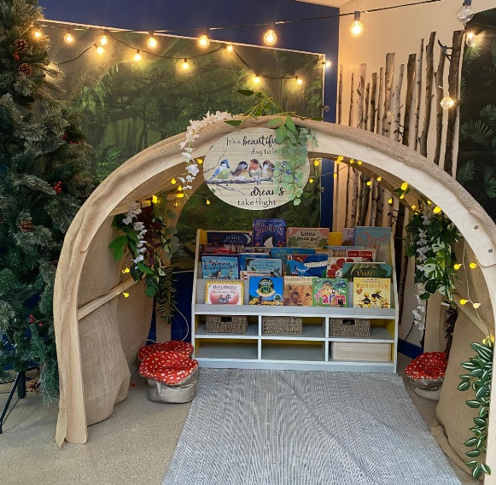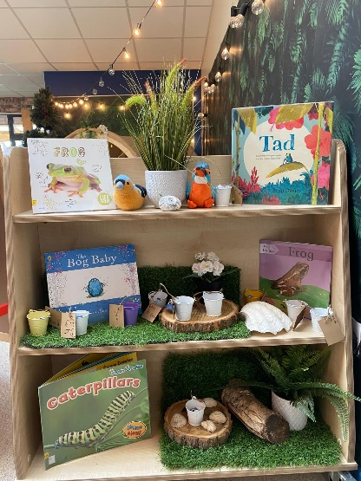

How you can prepare your child for school
- Encourage your child to dress and undress independently including fastening buttons, coats and shoes.
- Read and enjoy books and other texts together. Make it a happy experience so that they develop a love of reading. Discuss the characters, pictures and storyline with your child.
- Encourage your child to tidy away – We say “Choose it, use it and put it
away!”
- Sing nursery rhymes and counting rhymes together. Learn some off by heart.
- Help your child to recognise their name. If they are ready to write it please use lower case letters except for the initial letter, which should be a capital.
- Play turn-taking games such as snakes and ladders; make sure your child knows how to win and lose as well.
- Ensure your child can manage using the toilet by themselves, including washing their hands afterwards.
- Talk about numbers and teach your child to count objects accurately; you could involve your child in helping around the house by counting out the bowls or spoons needed to lay the table, counting steps up and down the stairs, look at house numbers or numbers on cars or buses as you go for a walk.
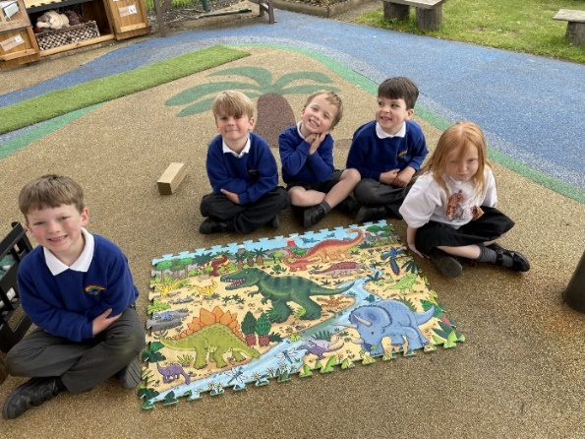
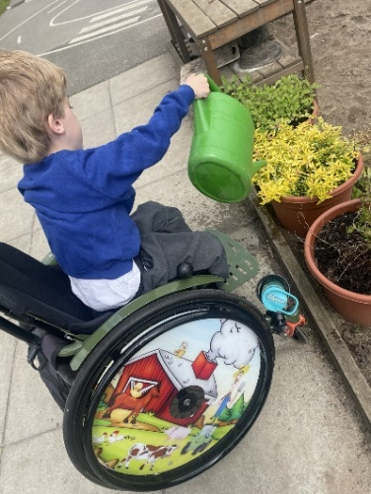
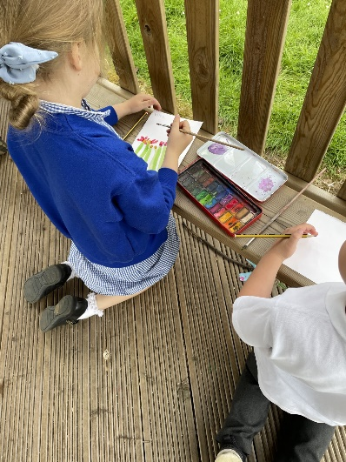

The Early Years Curriculum
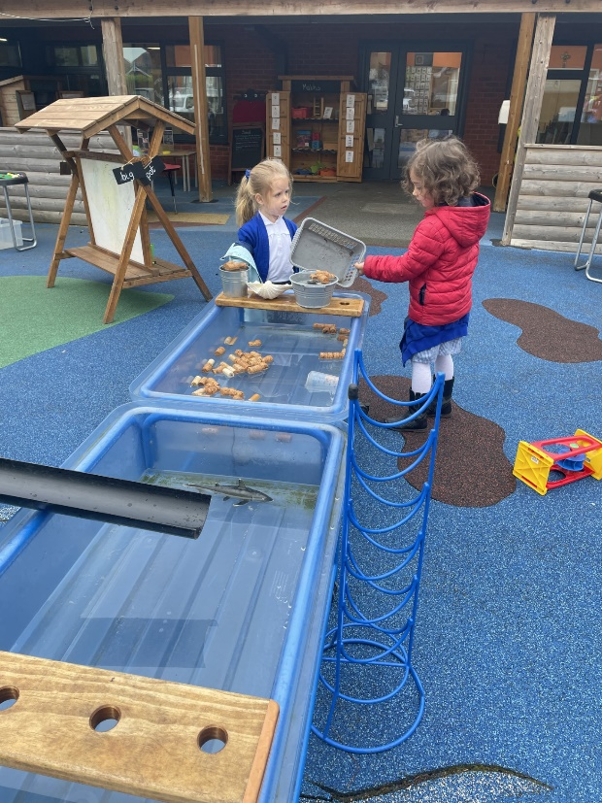
In the Early Years Foundation Stage, we know that children learn best through playing, exploring and immersing themselves in experiences. Our role as adults is to facilitate this through communicating and interacting, offering suggestions to develop the play and observing the children to plan where to take their learning next. We provide a safe and stimulating environment that enables children to flourish. We use a mixture of child initiated and adult directed learning. We recognise that the children planning and leading their own learning through their fascinations and interests is just as important as the sessions where the focus is more directed by us.
There will be daily Phonics, Maths and Literacy, with the afternoons taking a topic based approach. We will also have weekly PE sessions and much of our learning will take place in the great outdoors. Whether that be in our Foundation outdoor area, the wider school grounds or out in the community. We love a nature walk!
We build in regular opportunities to develop language, share ideas, problem solve and become critical thinkers.
In the Autumn term, we will invite you to a Foundation Curriculum Evening where we will talk more about how children learn in school and how you can support them at home.

